SmartCare v0.3 - Domain Model Workbook
Week 6 student resource

Requirement-to-Concept Trace
Requirement | Concept | State/behaviour | Decision
FR-01 create patient record identified by name | Patient | State: name. Behaviour: validate name is not empty | Class. Persistent identity and state the system must remember
FR-02 create practitioner record identified by name | Practitioner | State: name. Behaviour: validate name is not empty | Class. Same test as patient
FR-03 Book an appointment with patient, practitioner, date/time, status Booked | Appointment | State: patient, practitioner, date/time, status. Behviour: created in the Booked state | Class. Holds state no single participant owns
FR-04 reject booking where practitioner already booked at that time | AppointmentBook | Behabiour: check the existing set before creating | Class. No single Appointment can see the others
FR-05 reject booking where a name is empty, naming the field | Patient, Practitioner | Behaviour: is_valid() on each | Behaviour placed on the class that owns the name
FR-06 Change status to record attendance | Appointment | Behaviour: mark_attended(), mark_did_not_attend() | Behaviour on appointment, which owns the status
FR-07 Cancel by setting status to Cancelled | Appointment | Behaviour: cancel() | Behaviour on Appointment
FR-08 Retain cancelled and past appointments in history | AppointmentBook | State: the full appointment list, nothing removed | Retention is a property of the collection, not of one appointment
FR-09 Display all appointments with status booked | AppointmentBook | Behaviour: booked_appointments() | Query across the set
FR-10 Display appointments for a practitioner with cancelled count | AppointmentBook | Behviour: appointments_for(), cancelled_count_for() | Query across the set
FR-11 search patients by name, case insensitive partial | PatientRegister, Patient | Behaviour: find_by_name() on the register, matches_name() on the patient | Split: the register iterates the patient decides whether it matches
FR-12 Count appointments in a date range, Booked or Attended | AppointmentBook, Appointment | Behaviour: count_between(), occurs_between() | Same split as FR-11
NFR-02 Logic contains no display code | All classes | No print statements in any domain class | Constrains the model: no class produces output
NFR-06 patient, practitioner and date/time never change | Appointment | No setters for those three attributes | Enforced structurally not by convention
Appointment status set (assuming) | Appointment | Permitted values: Booked, Attended, Did Not Attend, Cancelled | Attribute with the values as module constants, not a class. Assumtpion-based still an open question
Clinic, Database persistence, Name, Status, Appointment history, Notification reminder, user, login, role rejected

CRC Cards
Just copied and pasted from the tut page.

Patient
Responsibilities | Collaborators
Know its own name (FR-01)
Report whether it matches a search term (FR-11) | PatientRegister
Report whether its name is valid (FR-05) | AppointmentBook

Practitioner
Responsibilities | Collaborators
Know its own name (FR-02)
Report whether its name is valid (FR-05) | AppointmentBook

Appointment
Responsibilities | Collaborators
Know its patient, practitioner, date/time and statuss (FR-03) | Patient, Practitioner
Change its own status to Attended or Did Not Attend (FR-06)
Cancel itself (FR-07)
Report whether it is Booked (FR-09), belongs to a practitioner (FR-10), occurs at a time (FR-04) or falls in a range (FR-12) | AppointmentBook

Optional class: AppointmentBook
Responsibilities | Collaborators
Hold every appointment, including cancelled and past ones (FR-08) | Appointment
Create a booking, rejecting clashes and empty names (FR-03, FR-04, FR-05) | Appointment, Patient, Practitioner
Report whether a practitioner is free at a date/time (FR-04) | Appointment, Practitioner
List booked appointments (FR-09) and a practitioners appointments with a cancelled count (FR-10) | Appointment
Count appointments in a date range (FR-12) | Appointment

Optional class: PatientRegister
Responsibilities | Collaborators
Hold every patient record (FR-01) | Patient
Create a patient record (FR-01) | Patient
Return patients matching a search term (FR-11) | Patient

UML Class Diagram
Insert/draw UML here. Include defensible relationships and multiplicities.
Reference: Created via draw.io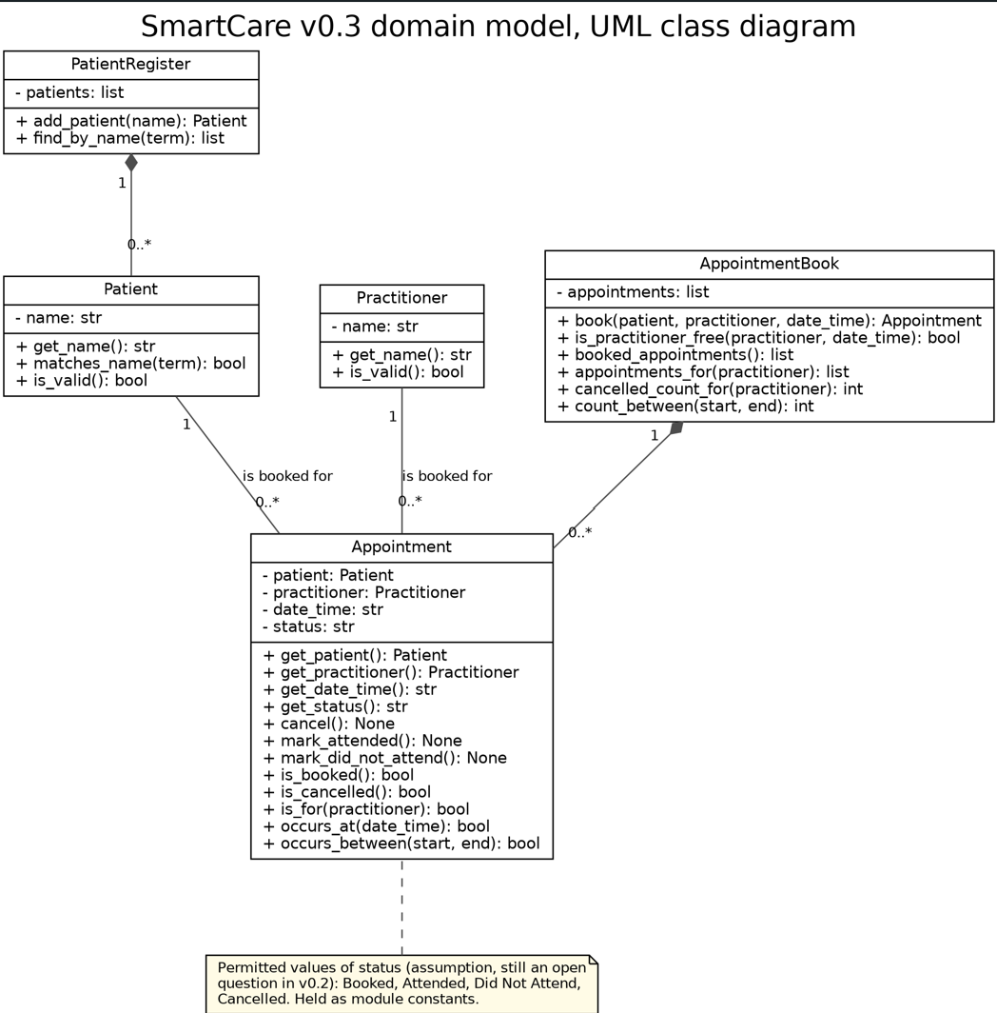

Design Rationale
Explain class selection, responsibility allocation and key relationships.
Each of the 5 holds state the system must remember and behaviour traceable to a confirmed requirement. Patient and Practitioner are entities with persistent identity: two patients with the same name are still two patients, which is why v0.2 flags name-only identity as an open question. Appointment holds state neither participant owns alone
Why the two collection classes: FR-04, FR-08 to FR-12 ask questions no individual object can answer like checking for a clash means seeing every appointment. Putting that on Appointment would make each one reference every other. These are not managers. A manager has behaviour and no state; AppointmentBook holds the records themselves and the book of appointments is what the clinics paper records already are. Every operation on both collections traces to one requirement. Where a query iterates, the object still owns the test: find_by_name iterates, matches_name decides.
Why a PatientRegister but no PractitionerRegister
FR-11 requires a search across patient records, so something must hold and iterate them. No requirement searches or lists practitioners. That covers searching but not storage: FR-02 requires practitioner records to be held, and nothing in v0.3 does so. This is recorded as a gap rather than closed, because adding a register for symmetry means a class with one operation and no requirement asking for it.
Why no inheritance
Patient and Practitioner share one attribute and one validation rule. Inheritance must express a genuine is-a relationship rather than code reuse, so a Person superclass would add a class no requirement asks for.
Why composition for the collections, association for the participants
The book creates its appointment records and they have no life outside it, which FR-08 reinforces by keeping cancelled ones there. An appointment does not stop existing when a patient record does, so that relationship stays a plain association.
Where the model records what is not known
The status values are an assumption, held as constants rather than modelled as a concept. Patient carries only a name, since further fields are provisional in v0.2. There is no edit operation, matching the Stage 2 assumption that correcting a booking means cancelling and rebooking.
Conventions
Double underscore attributes and pass bodies follow the lecture material, so the skeletons read as part of the same body of work as earlier stages.

AI Design Review Record
Gave Copilot the confirmed requirements and asked to propose classes, responsibilities and relationships, Twelve proposals were returned, have selected 5 below for the table
AI suggestion | Evidence | Decision | Reason | Model change
Separate the appointment collection from the appointment itself | Evidence-based. FR-04, FR-09, FR-10, FR-12 each reason over the whole set | Accept | No single appointment can see the others so without this class four requirements have no owner | AppointmentBook added, six operation each traced to a requirement
AppointmentManager handling booking, persistence and display | Partly evidence-based | Modified | Booking traces to FR-03 and FR-04, so the coordinating class is justified. Persistence and display are not: NFR-02 requires logic with no display code | Adopted as appointmentBook with booking and query responsibilities only
Patient with name, date of birth, address , phone and email | Not evidence-based | Modified | Fields beyond the name as provisional. Adding four uncofimed attributes would be inventing features | Patient modelledwith name only matching FR-01
NotificationManager for appointment reminders | Contradicted | Rejected | Patient facing notifications are out of scope | None
A person superclass that patient and practitioner inherit from | Weak | Rejected | The shared leement is a single attribute. Inheritance for code resue rather than a genuine is-a distinction and no requirement calls for it | None

